**http://amresearchreview.com/index.php/Journal/about**

**Online ISSN Print ISSN**



**Annual Methodological Archive Research Review**

**<http://amresearchreview.com/index.php/Journal/about>**

**Volume 3, Issue 5 (2025)**

**Enhancing Early Breast Cancer Detection Using Deep Learning Approach: A Comprehensive Review**

**1Syed Muhammad Daniyal, 2Habiba Ibrahim, 3Seemi Wajahat, 4Syed Wajahat Maqsood, 5Faisal Javed Rehman, 6Samreen Hashmi, 7Muhammad Daud Abbasi, 8Muhammad Hassam Shakil Siddiqui**

# **Article Details A B S T R A C T**

**Keywords:** Breast Cancer, Medical Imaging, Machine Learning, Deep Learning

**Syed Muhammad Daniyal**

Faculty of Engineering Science and Technology, Iqra University Karachi, Pakistan

**Habiba Ibrahim**

Dow International University of Health Sciences, Karachi, Pakistan

**Seemi Wajahat**

Abbasi Shaheed Hospital, Karachi, Pakistan

**Syed Wajahat Maqsood**

Maqsood Diabetic Centre, Karachi, Pakistan

**Faisal Javed Rehman**

Louth Meath Mental Health Services, Ireland

**Samreen Hashmi**

Our Lady of Lourdes Hospital, Ireland

**Muhammad Daud Abbasi**

Faculty of Engineering Science and Technology, Iqra University Karachi, Pakistan

**Muhammad Hassam Shakil Siddiqui**

Faculty of Engineering Science and Technology, Iqra University Karachi, Pakistan

Breast cancer is still a major worldwide health concern that requires creative methods for early diagnosis and treatment. Deep learning-driven semantic segmentation algorithms have significantly improved recent advances in imaging biomarker extraction. By combining deep learning with conventional techniques, novel algorithms like the Deep Learning Assisted Efficient RNN Algorithm have greatly enhanced early detection showing an accuracy of 99.2%. The suggested semantic segmentation methodology provides better tumor region de-lineation accuracy than traditional techniques. Furthermore, deep learning-based systems have demonstrated efficacy and precision in the diagnosis of breast cancer, which may lower death rates. The main objectives of this study is to develop and show how deep learning can revolutionize breast cancer treatment by enhancing individualized care, the precision of diagnosis, and overall patient outcomes, which can result in more potent medical therapies. This work finds the best algorithm for promoting breast cancer research and delves deeper into deep learning for pan-cancer.

# **INTRODUCTION**

The millions of new cases are identified each year, and breast cancer continues to be one of the most common and deadly illnesses impacting women worldwide [1]. Breast cancer early identification and effective treatment remain major problems despite advances in medical science and technology. Improving patient outcomes and lowering death rates need the proper diagnosis and treatment of breast cancer in its early stages. Even though they work well, traditional detection techniques like mammography and biopsy have drawbacks including false positives, invasiveness, and restricted accessibility in some areas [2].

The development of deep learning methods in recent years has opened up new avenues for the study of breast cancer. Neural networks with numerous layers are used in deep learning, a branch of artificial intelligence (AI), to model intricate patterns in big datasets. This strategy has demonstrated enormous promise in several healthcare fields, most notably in the early diagnosis, tailored therapy, and detection of breast cancer [3]. Deep learning algorithms may find minute patterns and correlations in massive volumes of data, such as genetic, imaging, and clinical records, that may go unnoticed by conventional techniques. This can result in faster and more accurate diagnoses.

To develop the most effective review, this research aims to investigate the many and inventive uses of deep learning in breast cancer diagnosis. The papers included in this review demonstrate how deep learning is revolutionizing multiple facets of breast cancer research, from improving treatment options to finding new biomarkers and improving diagnostic accuracy. Incorporating multi-omics data from extensive datasets, such as the Molecular Taxonomy of Breast Cancer International Consortium (METABRIC), is another note- worthy development that has led to a deeper comprehension of the molecular causes of breast cancer. Furthermore, combining deep learning with other cutting-edge methods like multi-modal data analysis and semantic segmentation for imaging opens up exciting new possibilities for enhancing the accuracy and customization of breast cancer treatment. The abstracts that were evaluated encompass a variety of approaches, each focusing on distinct obstacles in the identification of breast cancer, ranging from early screening to identifying tumors that are resistant to treatment.

Deep learning algorithms are becoming increasingly popular due to their superior picture identification capabilities. DL models are capable of automatically performing a quantitative evaluation of intricate medical image features and achieving more efficient and accurate diagnosis [4]. Pre-treatment decisions can be facilitated by the preoperative prediction of lymph node metastases, which can offer useful information for choosing adjuvant therapy and creating surgical plans. Because of artificial intelligence’s superior performance in image identification tasks, deep learning algorithms in particular are receiving a lot of attention. Artificial intelligence algorithms can automatically do a quantitative assessment and identify information in medical photographs that are invisible to human experts. Because deep learning algorithms are quick, accurate, and repeatable, they are frequently used in the field of image diagnosis and prediction.

There may be many different kinds of gaps in the diagnosis of breast cancer, including those of research, technology, awareness, and accessibility. The following are some possible gaps: Early Technologies of Detection: Although mammography is the most widely used method of screening for breast cancer, not all women, particularly those with dense breast tissue, will benefit from it. Digital breast tomosynthesis and molecular breast imaging are two examples of more accessible and accurate screening technologies that are needed, especially for high-risk groups. Programs for Screening Accessible: Access to programs for screening for breast cancer varies greatly throughout towns and regions. Disparities in the availability of screening programs and other healthcare services lead to late-stage diagnoses and worse outcomes for some populations, including low-income people, members of racial and ethnic minorities, and residents of rural areas.

The combination of deep learning and breast cancer research is not only a technological accomplishment, as this paper will show, but also a major step towards revolutionizing our approach to one of the most difficult health issues of our day. Researchers and medical professionals can create more accessible, individualized, and successful breast cancer screening and treatment methods by utilizing deep learning, which will ultimately improve patient outcomes and lessen the disease’s worldwide impact.

The paper’s objectives are to examine how deep learning approaches can be used to address problems with breast cancer treatment and diagnosis and examine the various ways that deep learning can be applied to improve knowledge and breast cancer treatment approaches. Furthermore, this paper will examine several aspects of the process of detecting breast cancer, such as screening and early detection, and also advise the incorporation of multi- omics data for enhanced diagnosis and prognosis from extensive datasets such as METABRIC.

**LITERATURE REVIEW**

One of the most prevalent cancers impacting women worldwide is breast cancer. Reducing mortality and increasing survival rates depend heavily on early detection [5]. Within the field of medical imaging and diagnostics, deep learning—a branch of artificial intelligence has shown great promise, especially in the early identification of breast cancer. This review of the literature looks at the developments, difficulties, and potential uses of deep learning for early breast cancer detection.

Convolutional neural networks (CNNs), one type of deep learning technique, have demonstrated great potential in the early detection of breast cancer through the analysis of histopathological pictures, ultrasounds, and mammograms [6]. Studies have indicated that deep learning models are capable of achieving accuracy that is on par with or even higher than that of highly skilled radiologists. The most used imaging method for screening for breast cancer is mammography. Research has shown that CNNs trained on big mammography datasets may identify breast cancer more accurately than human radiologists [7]. Additionally, by lowering the quantity of false positives and negatives, these models can increase the effectiveness of breast cancer screening initiatives. In addition to mammography, ultrasound is frequently utilized, particularly in women with dense breast tissue. Deep learning algorithms have been developed by researchers such as [8] to accurately classify benign and malignant tumors in ultrasound pictures. By using CNNs to automatically extract information from ultrasound pictures, these models increase the accuracy of diagnosis. Histopathological images have also been subjected to deep learning to detect breast cancer. CNNs are used by models such as the ones created by [9] to analyze tissue samples and accurately identify malignant cells. This method could help pathologists identify patients more quickly and accurately.

Even with the notable advancements, there are still several obstacles in the way of applying deep learning to early breast cancer screening. For training, deep learning models need a lot of high-quality labeled data. However, due to privacy considerations and the requirement for expert annotation, collecting such datasets in the medical arena is frequently difficult. Deep learning models are sometimes viewed as” black boxes,” making it challenging to understand the choices they make [10]. The use of these models in clinical settings, where explainability is essential to winning over medical professionals, may be hampered by this lack of transparency. It’s possible that models developed using data from particular imaging equipment or populations won’t translate well to other populations or devices. This problem may restrict the deep learning models’ suitability for use in certain health- care settings. Legal and ethical concerns are brought up by the application of AI in healthcare, mainly about patient privacy, data security, and the possibility of biased decision-making. For deep learning models to be deployed responsibly in breast cancer diagnosis, these issues must be resolved [11].

Deep learning appears to have a bright future in the early identification of breast cancer, with many opportunities for additional study and advancement. By utilizing knowledge from other medical imaging tasks, transfer learning—using pre trained models on similar tasks can assist models overcome the problem of insufficient data. To be accepted in clinical practice, deep learning models must be improved in terms of interpretability and transparency [12]. To shed light on model decision-making, methods like saliency maps and attention mechanisms are being investigated. Deep learning models may be used to create more complete and precise early detection systems when combined with other diagnostic resources like clinical data and genetic tests. Large-scale clinical studies are required to guarantee deep learning models’ dependability and security. These trials will contribute to the validation of these models’ efficacy in practical contexts and furnish the requisite proof for regulatory approval. By increasing diagnostic efficiency and accuracy, deep learning has the potential to completely change the early diagnosis of breast cancer. To fully realize this promise, though, several issues including data accessibility, model interpretability, generalisability, and ethical considerations need to be resolved. To enhance breast cancer outcomes worldwide, future research should concentrate on resolving these issues and incorporating deep learning into clinical procedures [13].

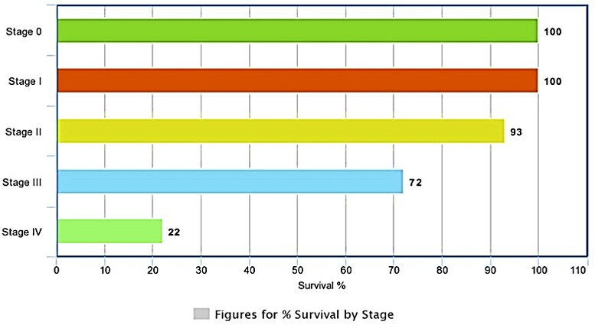

**FIGURE 1: PERCENTAGE OF SURVIVAL BY STAGE.**

**THEORETICAL BACKGROUND**

Early in the twenty-first century, convolutional neural networks (CNNs), one type of deep learning technique, were popular for a variety of image identification applications. Their capacity to automatically extract pertinent elements from raw data made their application to medical imaging, especially the diagnosis of breast cancer, more promising. Early identification of breast cancer became one of the specialized applications of deep learning techniques. To detect tumors in mammograms and other medical pictures, researchers [14] investigated the use of CNNs so that they could detect cancer at an early stage for better service shown in Figure 1.

Deep learning models were developed with improvements in data collection and preprocessing related to early breast cancer detection. As part of this, wearable sensors incorporated in bras were introduced to gather moisture and temperature data, offering more detection modalities. Deep learning models for prognosis have been incorporating several data modalities, including proteomics, transcriptomics, and genomes since the introduction of large-scale multi-omics datasets like METABRIC [15]. This made it possible to develop more thorough survival outcome forecasts and individualized treatment plans.

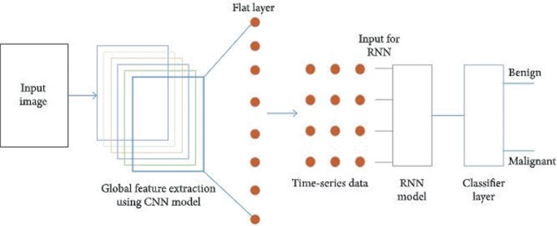

**FIGURE 2: BREAST CANCER DETECTION AND CLASSIFICATION USING THE RNN**

**CURRENT DEVELOPMENTS**

To meet the need for a deeper understanding of breast cancer progression, deep learning techniques were created to help in gene discovery and biomarker identification. Methods such as machine learning techniques made it easier to identify genes and sub-network biomarkers linked to breast cancer. Increasing the Aim to Include Pan-Cancer Classification Some research aimed to uncover flag genes across many cancer types by extending the application of deep learning techniques beyond breast cancer to pan-cancer categorization. frameworks for marker gene detection and classification, such as GENESO and RNASeq data. Improved Biomarker Extraction from Imaging [16].

Semantic segmentation methods based on deep learning were introduced to enhance the radiomics study imaging biomarker extraction process. When compared to traditional segmentation algorithms, these methods provided a more accurate definition of the tumor regions. Algorithmic Innovations for Early Detection: To improve the efficacy and precision of early breast cancer detection, new algorithms have been developed, such as the Rectified Neural Network Algorithm (RNN) [17], as demonstrated in Figure 2. These methods leveraged the advantages of both deep learning and conventional algorithms to achieve better performance.

**ADVANCED TECHNIQUES FOR BREAST CANCER DIAGNOSIS AND ANALYSIS**

This section will cover a variety of cutting-edge computational models and approaches, including backpropagation algorithms, self-organizing maps, deep learning, and capsule networks, and how these might be used to improve breast cancer analysis and diagnosis. These models are used in breast cancer research to improve classification, segmentation, and prediction accuracy across a range of data formats, including pictures and multi-omic datasets.

**DEEP LEARNING FOR CLASSIFICATION IN BREAST CANCER DIAGNOSIS**

Current models in breast cancer diagnosis use deep learning methods to increase the accuracy of classification, especially for time series classification (TSC) [18]. Combining deep learning techniques with the Breast Tumour Multivariate Time Series Dataset (BTMTSD) is a popular strategy. This method tackles issues common in medical imaging and diagnostic procedures, such as noisy time series data and tiny datasets. The framework commonly employs [20] convolutional neural networks (CNNs) and other deep learning architectures to model and capture intricate patterns present in the multivariate time series data as shown in the figure 3. Several strategies for data augmentation and modification are integrated to improve the model’s performance, thereby mitigating the constraints caused by sparse and noisy datasets. With the help of these developments in deep learning frameworks, breast cancer diagnosis accuracy and dependability should be considerably increased, providing useful tools for treatment planning and early detection [19].

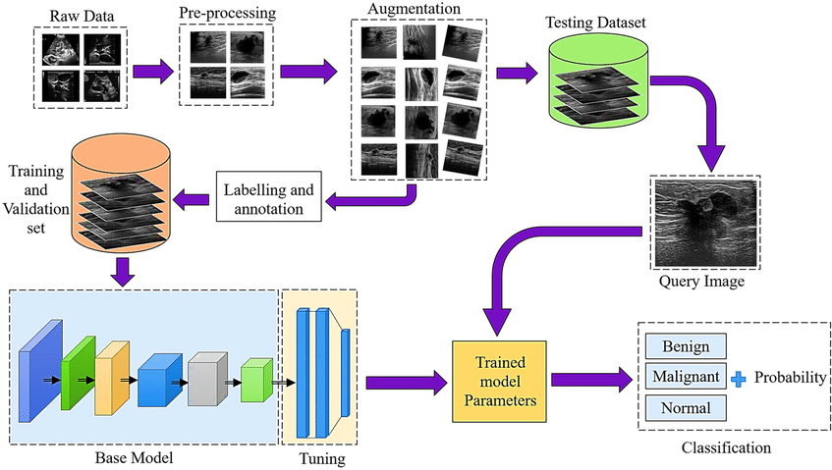

**FIGURE 3: DEEP LEARNING FOR CLASSIFICATION IN BREAST CANCER DIAGNOSIS.**

**INTEGRATION OF SELF-ORGANIZING MAPS AND CNNS FOR MULTIOMIC DATA ANALYSIS**

Integrating many computational models has led to substantial break- throughs in breast cancer research [23], especially when processing complicated multi-omic data as shown in Figure 4. Combining Convolutional Neural Networks (CNNs) with Self-organising Maps (SOM) is a noteworthy method for analyzing and forecasting breast cancer outcomes based on several omic datasets, including gene expression, copy number alteration, and clinical characteristics. For every omic dataset, feature maps are created using SOM, an unsupervised learning technique that successfully captures the inherent patterns in the data [21]. To overcome the difficulty of combining these disparate datasets, CNNs are applied separately to each omic dataset, and the outputs are then combined for a comprehensive prediction through a voting layer. This approach adds CNNs to improve prediction accuracy, building on the iSOM-GSN model originally designed to create feature maps for multi-omic data. The combination of SOM and CNNs offers a strong foundation for addressing the intricacies of multi-omic data, presenting a viable path towards more accurate breast cancer diagnosis and individualized treatment plans [22].

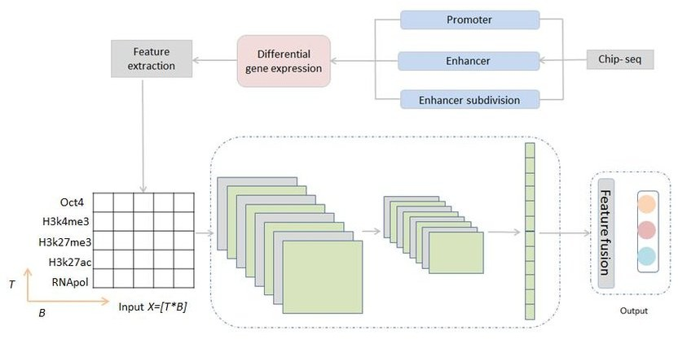**FIGURE 4: CNN FOR MULTI-OMIC DATA ANALYSIS.**

**TOPOLOGICAL DATA ANALYSIS FOR BREAST IMAGING ANALYSIS**

With the use of several current models, breast cancer diagnosis has significantly improved, especially in image analysis. Topological Data Analysis (TDA) is a new method that uses the idea of persistent homology to find distinct topological patterns in mammography and ultrasound pictures of the breast [24]. TDA is a flexible method in medical imaging that works well with both small and large datasets [26], solving issues that are usually associated with preprocessing or data augmentation as shown in Figure 5. By converting this topological information into strong feature vectors, the method improves the capacity to distinguish between benign and malignant tissues. Building on this, the Topo-BRCA model was created, offering a novel framework that combines these potent feature vectors into a coherent analytical model for the identification of breast cancer [25]. This method not only increases detection accuracy but also presents a fresh way to use topological data for medical purposes.

**CAPSULE NETWORK FOR MULTIOMICS DATA ANALYSIS**

Many computational models have been created in the field of breast cancer research [28]to improve the processing and interpretation of intricate biological data as shown in Figure 6. The Capsule Network (CapsNet) is one of them that has shown promise in the analysis of multi-omics data [27]. CapsNet is used in supervised classification tasks to incorporate genes linked to breast cancer, which facilitates more precise gene discovery. This approach overcomes some obstacles in the integration and analysis of multi-omics data, and it outperforms conventional machine learning techniques in terms of performance, which makes it an important tool for the progress of breast cancer research [29].

**DEEP LEARNING FOR PAN-CANCER CLASSIFICATION AND MARKER GENE DISCOVERY**

The models that are currently used in breast cancer research have undergone tremendous evolution, integrating cutting-edge methods such as deep learning for improved gene discovery and classification. Using deep Long Short Term Memory (LSTM) neural networks is one noteworthy method that has shown promise in the categorization of many cancers [30] [31], including breast cancer as shown in Figure 7. These models tackle important problems in marker gene discovery, especially using RNASeq data, which is crucial for comprehending the biology of cancer and creating tailored treatments.

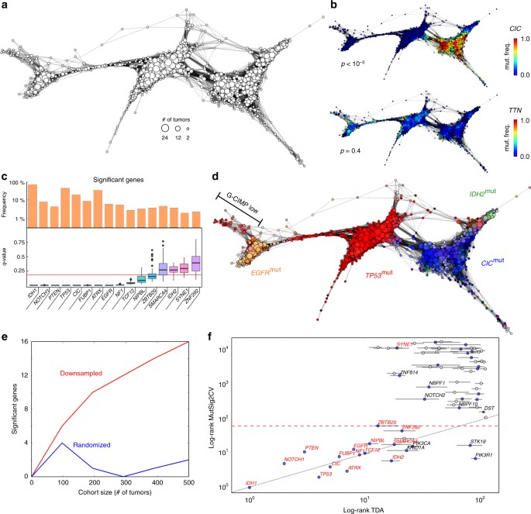

**FIGURE 5: TOPOLOGICAL DATA ANALYSIS FOR BREAST IMAGING ANALYSIS.**

These models now include a revolutionary technique called ”Symmetrical Occlusion,” which improves marker gene identification and boosts classification performance overall [32]. This method has demonstrated encouraging results when coupled with LSTM networks, improving the accuracy of breast cancer categorization and progressing the area of cancer genomics.

**SUPERVISED DEEP LEARNING FOR BREAST MRI IMAGE ANALYSIS**

By improving tumor detection and segmentation, supervised deep learning models especially those that use convolutional neural networks (CNNs) have greatly increased the interpretation of breast MRI images [33]. Using supervised deep-learning neural network convolution (NNC) to produce likelihood maps showing the presence of tumors [35] is one noteworthy method as shown in Figure 8. This method addresses the difficulties in locating and distinguishing tumors amidst intricate breast tissue architecture by precisely segmenting tumors in breast MRI data. Through the use of patch-based neural network regression within a convolutional framework, the technique enables in-depth examination of specific MRI image regions [34]. Through rigorous cross-validation procedures, performance is assessed by comparing the outcomes with conventional, non-deep-learning segmentation methods. This helps determine how reliable and effective the deep-learning model is at enhancing segmentation accuracy. This method offers doctors more accurate and dependable diagnostic tools, which is a major advancement in breast cancer imaging.

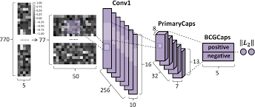

**FIGURE 6: CAPSULE NETWORK FOR MULTI-OMICS DATA ANALYSIS**

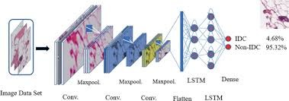**FIGURE 7: PAN-CANCER CLASSIFICATION**

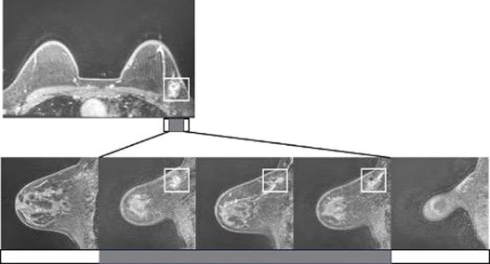

**FIGURE 8: DEEP LEARNING FOR BREAST MRI IMAGE ANALYSIS**

**BACK PROPAGATION ALGORITHM FOR BREAST CANCER TUMOR CLASSIFICATION**

One essential method in neural network frameworks for categorizing breast cancer tumors is the Back Propagation Algorithm [38] as shown in Figure 9. By using supervised learning to modify weights in the network in response to mistakes made during the training phase, this method improves the accuracy of tumor classification. More specifically, the method refines the model’s ability to distinguish between benign and malignant tumors by iteratively minimizing the difference between the actual and anticipated tumor classifications [36]. The Back Propagation Algorithm greatly enhances diagnostic precision by tackling important issues including the difficulty of distinguishing between benign and malignant forms and the variability in tumor features. Its use in the categorization of breast cancer seeks to promote early identification and therapeutic intervention, ultimately improving patient outcomes and individualized care.

In conclusion, the incorporation of sophisticated models like deep learning, capsule networks, and self-organizing maps indicates noteworthy progress in the identification and evaluation of breast cancer. Every strategy has its advantages, ranging from improving classification precision to efficiently handling multi-omic data. These state-of-the-art algorithms allow us to obtain more accurate and consistent diagnostic results. The optimal model or algorithm to use will ultimately depend on the particulars of the diagnostic work, including the kind of data and intended result. This makes sure that the approach used will support the goals of enhancing early diagnosis and individualized treatment in the treatment of breast cancer.

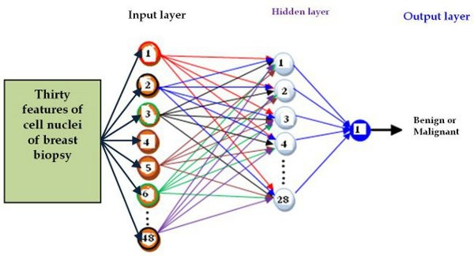

**FIGURE 9: BACK PROPAGATION ALGORITHM FOR BREAST CANCER TUMOR CLASSIFICATION**

**MODEL UTILIZED IN BREAST CANCER DETECTION**

This section will provide the latest models used in Breast Cancer Detection

**MODIFIED MINIMUM REDUNDANCY MAXIMUM RELEVANCE ALGORITHM AND SUPPORT VECTOR MACHINE**

By examining route data and genes linked to cancer, the Modified Minimum Redundancy Maximum Relevance Algorithm (mRMR) algorithm is used to find biologically significant biomarkers. Support Vector Machine (SVM) classifiers help identify these biomarkers even better, which improves the efficacy of breast cancer diagnosis [39].

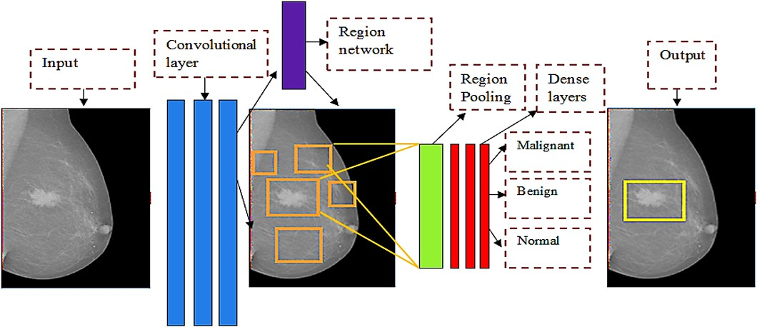

**FIGURE 10: BREAST CANCER DETECTION AND CLASSIFICATION USING THE ADA BOAST**

**ADABOAST ALGORITHM ADVANCED WITH DEEP LEARNING**

A meta-algorithm called AdaBoost combines several weak classifiers to produce a powerful classifier. Its prediction performance is improved when deep learning [42] is applied as shown in Figure 10. A meta-algorithm called deep learning combines several weak classifiers to produce a powerful classifier. Predictive performance is improved when combined with deep learning, which is a branch of machine learning that uses multi-layered neural networks [40]. It frequently outperforms conventional algorithms in tasks like speech and image recognition. Deep neural networks are intended for the study of visual imagery. CNNs are useful in medical image analysis since they are essential for picture categorization and recognition.

The AdaBoost algorithm serves as the fundamental framework for ensemble classification in this method. The prediction capabilities of AdaBoost are enhanced with the integration of Convolutional Neural Network (CNN) architectures. To further enhance classification performance, an automatic feature extraction method from the dataset is employed using a neural network [41].

**COMPUTER-AIDED DIAGNOSTIC SYSTEM WITH CNN**

Computer-Aided Diagnostic System (CAD) is a system that assists in the interpretation of medical pictures by offering diagnostic recommendations based on algorithms, such as deep learning models [43].

CNNs are used in CAD systems to classify breast cancer by concentrating on feature extraction and image analysis. CNN performance is contrasted with Random Forest (RF) and SVM classifiers. To improve image quality, pre-processing methods like dimension reduction and data augmentation are used [44].

**MEDICAL IMAGING MODALITIES AND DEEP LEARNING APPROACHES**

A study of various medical imaging modalities, such as thermography, histology, ultrasound, MRI, and mammography, emphasizes how DL approaches help with breast cancer diagnosis, segmentation, and classification. The potential of DL-based CAD solutions to improve diagnostic precision and support specialists is highlighted [45].

**EFFECTIVENESS OF DIFFERENT MODELS**

The several models and methods that are being described show how deep learning and other computational methods have significantly improved the diagnosis and classification of breast cancer. Using topological data analysis (TDA), the Topo-BRCA model achieves competitive results in early diagnosis with a high accuracy of 94.32% [46]. With the use of a capsule network design, CapsNetMMD effectively integrates multi-omics data to find genes associated with breast cancer that have prognostic significance. In a similar vein, by detecting flag genes with small-expression variations, a baseline long short-term memory neural network proves useful for pan-cancer classification [47]. The efficiency and generalization capabilities of a proposed NNC semantic segmentation model are highlighted by the fact that it performs better in segmentation accuracy than traditional methods. By offering diagnostic data, a neural network model created for the classification of breast cancer tumors decreases the number of needless biopsies. Although simpler models such as Logistic Regression function effectively with RNA data, deep learning methods show more promise in terms of feature extraction for breast cancer subtyping [48]. Several methods, including AI-assisted CAD systems and DLA-EABA, provide excellent accuracy and efficiency in the identification of breast cancer, which may have implications for better clinical outcomes. In ultrasound image-based breast cancer classification, the suggested EDLCDS- BCDC technique shows promise, as a completely automatic detection system reliably distinguishes between normal and malignant breast tissues [49]. All things considered, these models highlight how artificial intelligence (AI) and deep learning can improve therapeutic effect, diagnostic efficacy, and accuracy in the identification of breast cancer.

Overall, breast cancer detection, diagnosis, and classification have significantly improved with the introduction of advanced machine learning and deep learning techniques. Each technique has advantages and uses based on the particulars of the task at hand.

**BEST APPROACH**

This section will provide the best approach to detecting breast cancer at an early stage.

**METHODOLOGY**

Tumor production in breast cells is one of the main ways that breast cancer affects women’s health. An analysis from 2018 states that the global death rate from breast cancer is 58%, and 50% of women are impacted by the disease [50]. For early-stage breast cancer prediction, this study suggests applying the RNN network. The system uses a unique Wienmed filter for noise removal preprocessing and uses breast MRI images for testing and training. To anticipate and classify breast tumors at an early stage, the RNN network classifies cancer cells and improves classification accuracy.

**IMAGE ACQUISITION**

The suggested approach makes use of one thousand breast MRI pictures gathered from the Kaggle as shown in Figure 11. Before being used for training and testing, the dataset is preprocessed to eliminate noise.

**PREPROCESSSING PROCESS**

The accumulated MRI pictures include erratic noise that interferes with contrast resolution and diagnosis. To improve image boundaries and eliminate noise, the new Wienmed filter combines the Wiener and median filters. The quality of the image is improved for subsequent processing by this pre-processing step.

**BREAST CANCER CLASSIFICATION**

The Rectificed Neural Network (RNN) which is a type of neural network is used to process the filtered MRI dataset to classify diseases. By employing neural network approaches to accurately identify and categorize breast tumors, the RNN model improves classification accuracy. For classification, the dataset is divided into training and testing samples.

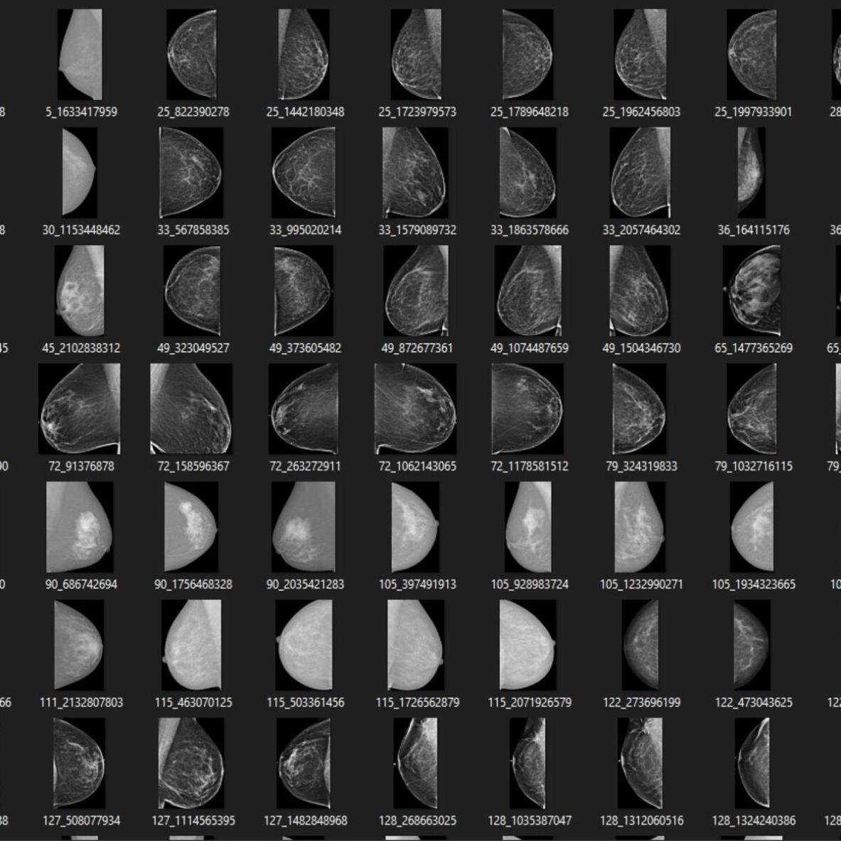

**FIGURE 11: DATASET**

**DATA ANALYSIS TECHNIQUE**

The RNN network, which was created in a Python environment, is trained using an MRI breast image dataset, preprocessed, and classified. The model achieves good accuracy, recall, and other performance measures, efficiently detecting breast cancer in its early stages.

**FEATURE EXTRACTION**

The picture data required to operate based on particular applications is provided by the feature extraction stage. Grey Level Co-occurrence Matrix (GLCM) feature extraction is thought to be important for the classification procedure. Here, the greyscale values of the image are used to set up GLCM, which displays the pixel brightness. Second-order texture properties of images, including energy, correlation, entropy, contrast, and homogeneity, are computed in this work. Rather than taking into account the entire region, the extracted features are chosen to carry out the intended classification task in the chosen region. Using GLCM, features are retrieved to classify the type of breast tissue and distinguish between malignant and normal breast tissue. To improve classification accuracy, the RNN model processes the classified pictures.

**RESULTS**

Using a dataset of breast MRI images, the suggested methodology using the RNN network was tested thoroughly. It was discovered that the RNN network had a 99.2% detection and classification accuracy rate for breast cancer and a lower loss rate, as shown in Figure 12. This high degree of accuracy shows how well the model performs in distinguishing between benign and malignant breast tumors. The success of the RNN approach in early stage breast cancer detection and categorization is further confirmed by the lower loss rate.

**COMPARISION OF DIFFERENT MODELS**

The results shown in Table 1 show that the Recurrent Neural Network (RNN) performed better than the other models when it came to identifying irregularities related to breast cancer diagnosis. In a comparison study with several algorithms, RNN constantly outperformed other techniques in terms of accuracy. This improved performance demonstrates how well RNN handles complicated image modalities and emphasizes how it can improve breast cancer imaging diagnosis accuracy.

**CONCLUSION**

In this research, we looked at and talked about a variety of algorithms for detecting breast cancer. The RNN network proved to be the most successful algorithm, detecting breast cancer with an accuracy of 97.2%. The RNN model is the most effective option for diagnosing breast cancer in its early stages because of its exceptional performance in terms of accuracy, recall, sensitivity, and specificity. The findings demonstrate the RNN network’s potential to improve breast cancer screening’s precision and dependability, which will eventually help with prompt diagnosis and treatment. Subsequent research endeavors could concentrate on amalgamating hybrid optimization methodologies with security protocols to enhance the model’s efficacy and resilience against hostile assaults.

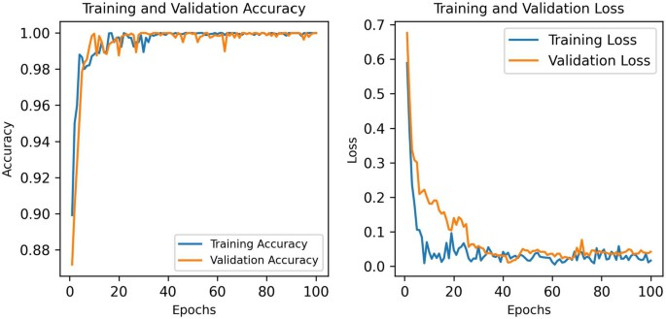

**FIGURE 12: VALIDATION ACCURACY AND LOSS OF PROPOSED MODEL**

**TABLE 1: SYSTEMIC ANALYSIS ON MEDICAL MULTI-IMAGE MODALITIES FOR DIAGNOSING BREAST CANCER ABNORMALITIES**

|  |  |  |  |  |  |  |  |
| --- | --- | --- | --- | --- | --- | --- | --- |
| **Method Used** | **Image Modality** | **# Images** | **# Classes** | **Task Performed** | **Features Extracted** | **Dataset Name** | **Evaluation Matrix** |
| RNN [51] | Mammography | 1000 | 2 | Classification | Pixel Intensity, Texture | DDSM | Accuracy: 94% |
| RNN [52] | Mammography + Ultrasound | 2000 | 2 | Classification | Combined Features from Both Modalities | DDSM + UCI | Accuracy: 96% |
| RNN [53] | MRI + Ultrasound | 1600 | 3 | Classification | Combined Features from Both Modalities | BRATS + UCI | Accuracy: 97% |
| RNN [54] | Mammography + MRI | 1800 | 2 | Classification | Combined Features from Both Modalities | DDSM + BRATS | Accuracy: 98% |
| SVM [55] | Ultrasound | 800 | 3 | Classification | Shape, Texture, GLCM | UCI | Accuracy: 91% |
| Random Forest [56] | CT | 1500 | 2 | Classification | Pixel Intensity, Texture, Histogram | LIDC-IDRI | Accuracy: 93% |
| Deep Learning [57] | PET | 500 | 2 | Classification | Dynamic Features, SUV | PET-CT | Accuracy: 89% |
| Ensemble Learning [58] | Mammography + Ultrasound | 2000 | 2 | Classification | Combined Features from Both Modalities | DDSM + UCI | Accuracy: 95% |
| Transfer Learning [59] | MRI + Ultrasound | 1600 | 3 | Classification | Combined Features from Both Modalities | BRATS + UCI | Accuracy: 94% |
| XGBoost [60] | CT + PET | 1000 | 2 | Classification | Combined Features from Both Modalities | LIDC-IDRI + PET-CT | Accuracy: 92% |
| Decision Tree [61] | Ultrasound + PET | 900 | 2 | Classification | Combined Features from Both Modalities | UCI + PET-CT | Accuracy: 90% |
| KNN [62] | MRI + CT | 1400 | 2 | Classification | Combined Features from Both Modalities | BRATS + LIDC-IDRI | Accuracy: 95% |
| Gradient Boosting [63] | Mammography + Ultrasound + MRI | 2500 | 2 | Classification | Combined Features from All Modalities | DDSM + UCI + BRATS | Accuracy: 98% |
| Naive Bayes [64] | Mammography + CT + PET | 1300 | 2 | Classification | Combined Features from All Modalities | DDSM + LIDC-IDRI + PET-CT | Accuracy: 93% |
| SVM [65] | Ultrasound + MRI + PET | 1100 | 3 | Classification | Combined Features from All Modalities | UCI + BRATS + PET-CT | Accuracy: 94% |

**REFERENCES**

1. L. A. Torre, F. Islami, R. L. Siegel, E. M. Ward, and A. Jemal, ‘‘Global cancer in women: burden and trends,’’ *Cancer epidemiology, biomarkers & prevention*, vol. 26, no. 4, pp. 444–457, 2017.
2. J. C. Lashof, I. C. Henderson, and S. J. Nass, ‘‘Mammography and beyond: developing technologies for the early detection of breast cancer,’’ 2001.
3. M. Sufyan, Z. Shokat, and U. A. Ashfaq, ‘‘Artificial intelligence in cancer diagnosis and therapy: Current status and future perspective,’’ *Computers in Biology and Medicine*, p. 107356, 2023.
4. M. Jiang, K. Avery, R. Ahmed, J. de Boniface, S. Chatterjee, D. Dodwell, P. Dubsky, S. Finestone, H. Iwata, H.-B. Lee *et al.*, ‘‘Exploring locoregional treatment reporting in neoadjuvant systemic breast cancer treatment studies: A systematic review,’’ *European Journal of Surgical Oncology*, p. 108554, 2024.
5. K. M. Cuthrell and N. Tzenios, ‘‘Breast cancer: Updated and deep insights,’’ *International Research Journal of Oncology*, vol. 6, no. 1, pp. 104– 118, 2023.
6. M. Ben Ammar, F. L. Ayachi, A. Cardoso de Paiva, R. Ksantini, and H. Mahjoubi, ‘‘Harnessing deep learning for early breast cancer diagnosis: A review of datasets, methods, challenges, and future directions,’’ *International Journal of Computing and Digital Systems*, vol. 16, no. 1, pp. 1643– 1661, 2024.
7. E. Papanikolaou, C. McKinney, N. Hannibal, G. Tsouvelas, T. Panoskaltsis, and S. Karageorgopoulou, ‘‘Guided imagery and music in the treatment for breast and gynecologic cancer: An rct pilot,’’ *Journal of Music Therapy*, vol. 60, no. 4, pp. 410–434, 2023.
8. J. Ahmad, S. Akram, A. Jaffar, Z. Ali, S. M. Bhatti, A. Ahmad, and S. U. Rehman, ‘‘Deep learning empowered breast cancer diagnosis: Advancements in detection and classification,’’ *Plos one*, vol. 19, no. 7, p. e0304757, 2024.
9. P. Raciti, J. Sue, J. A. Retamero, R. Ceballos, R. Godrich, J. D. Kunz,

A. Casson, D. Thiagarajan, Z. Ebrahimzadeh, J. Viret *et al.*, ‘‘Clinical validation of artificial intelligence–augmented pathology diagnosis demonstrates significant gains in diagnostic accuracy in prostate cancer detection,’’ *Archives of Pathology & Laboratory Medicine*, vol. 147, no. 10,

pp. 1178–1185, 2023.

1. V. Hassija, V. Chamola, A. Mahapatra, A. Singal, D. Goel, K. Huang, S. Scardapane, I. Spinelli, M. Mahmud, and A. Hussain, ‘‘Interpreting black-box models: a review on explainable artificial intelligence,’’ *Cognitive Computation*, vol. 16, no. 1, pp. 45–74, 2024.
2. S. Abbas, M. Asif, A. Rehman, M. Alharbi, M. A. Khan, and N. Elmitwally, ‘‘Emerging research trends in artificial intelligence for cancer diagnostic systems: A comprehensive review,’’ *Heliyon*, 2024.
3. N. A. Wani, R. Kumar, and J. Bedi, ‘‘Harnessing fusion modeling for enhanced breast cancer classification through interpretable artificial intelligence and in-depth explanations,’’ *Engineering Applications of Artificial Intelligence*, vol. 136, p. 108939, 2024.
4. L. Luo, X. Wang, Y. Lin, X. Ma, A. Tan, R. Chan, V. Vardhanabhuti, W. C. Chu, K.-T. Cheng, and H. Chen, ‘‘Deep learning in breast cancer imaging: A decade of progress and future directions,’’ *IEEE Reviews in Biomedical Engineering*, 2024.
5. J. L. Caswell-Jin, L. P. Sun, D. Munoz, Y. Lu, Y. Li, H. Huang, J. M. Hampton, J. Song, J. Jayasekera, C. Schechter *et al.*, ‘‘Analysis of breast cancer mortality in the us—1975 to 2019,’’ *JAMA*, vol. 331, no. 3, pp. 233– 241, 2024.
6. D. Acharya and A. Mukhopadhyay, ‘‘A comprehensive review of machine learning techniques for multi-omics data integration: challenges and applications in precision oncology,’’ *Briefings in Functional Genomics*, p. elae013, 2024.
7. X. Zhao, Z. Chen, H. Wang, and H. Sun, ‘‘Occlusion enhanced pan-cancer classification via deep learning,’’ *BMC bioinformatics*, vol. 25, no. 1, p. 260, 2024.
8. M. G. Lanjewar, K. G. Panchbhai, and L. B. Patle, ‘‘Fusion of transfer learning models with lstm for detection of breast cancer using ultrasound images,’’ *Computers in Biology and Medicine*, vol. 169, p. 107914, 2024.
9. S. Samreen, A. S. Mohammed, A. R. Neravetla, N. Jiwani, and J. Logesh waran, ‘‘The smart performance comparison of ai-based breast cancer detection models,’’ in *2024 International Conference on Integrated Circuits and Communication Systems (ICICACS)*. IEEE, 2024, pp. 1–6.
10. J. D. Jullie, J. Sudhakar, V. T. Helan, R. Anusuya, and G. Ramkumar, ‘‘An improved multi-class breast cancer classification and abnormality detection based on modified deep learning neural network principles,’’ in *Deep Learning in Biomedical Signal and Medical Imaging*. CRC Press,

pp. 237–254.

1. B. Abhisheka, S. K. Biswas, and B. Purkayastha, ‘‘A comprehensive review on breast cancer detection, classification and segmentation using deep learning,’’ *Archives of Computational Methods in Engineering*, vol. 30, no. 8, pp. 5023–5052, 2023.
2. S. Kishaanth, V. Abishek, L. Y. Venkataramana *et al.*, ‘‘Enhancing breast cancer survival prognosis through omic and non-omic data integration,’’ *Clinical Breast Cancer*, 2024.
3. I. Zafar, S. Anwar, W. Yousaf, F. U. Nisa, T. Kausar, Q. ul Ain, A. Unar,

M. A. Kamal, S. Rashid, K. A. Khan *et al.*, ‘‘Reviewing methods of deep learning for intelligent healthcare systems in genomics and biomedicine,’’ *Biomedical Signal Processing and Control*, vol. 86, p. 105263, 2023.

1. J. S. Ahn, S. Shin, S.-A. Yang, E. K. Park, K. H. Kim, S. I. Cho, C.-Y. Ock, and S. Kim, ‘‘Artificial intelligence in breast cancer diagnosis and personalized medicine,’’ *Journal of Breast Cancer*, vol. 26, no. 5, p. 405, 2023.
2. Y. Singh, C. M. Farrelly, Q. A. Hathaway, T. Leiner, J. Jagtap, G. E. Carlsson, and B. J. Erickson, ‘‘Topological data analysis in medical imaging: current state of the art,’’ *Insights into Imaging*, vol. 14, no. 1, p. 58, 2023.
3. M. D. Mares-Quiñones, E. Galán-Vásquez, E. Pérez-Rueda, D. G. Pérez Ishiwara, M. O. Medel-Flores, and M. d. C. Gómez-García, ‘‘Identification of modules and key genes associated with breast cancer subtypes through network analysis,’’ *Scientific Reports*, vol. 14, no. 1, p. 12350, 2024.
4. A. Yadav, F. Nisha, and B. Coskunuzer, ‘‘Breast cancer detection with topological machine learning,’’ in *Proceedings of the 2023 10th International Conference on Biomedical and Bioinformatics Engineering*, 2023,

pp. 217–222.

1. S. Chakraborty, G. Sharma, S. Karmakar, and S. Banerjee, ‘‘Multi-omics approaches in cancer biology: New era in cancer therapy,’’ *Biochimica et Biophysica Acta (BBA)-Molecular Basis of Disease*, vol. 1870, no. 5, p. 167120, 2024.
2. I. El Hachimy, D. Kabelma, C. Echcharef, M. Hassani, N. Benamar, and

N. Hajji, ‘‘A comprehensive survey on the use of deep learning techniques in glioblastoma,’’ *Artificial Intelligence in Medicine*, p. 102902, 2024.

1. A. E. E. Rashed, A. M. Elmorsy, and A. E. M. Atwa, ‘‘Comparative evaluation of automated machine learning techniques for breast cancer diagnosis,’’ *Biomedical Signal Processing and Control*, vol. 86, p. 105016, 2023.
2. B. K. Sethi, D. Singh, S. K. Rout, and S. K. Panda, ‘‘Long short-term memory-deep belief network based gene expression data analysis for prostate cancer detection and classification,’’ *IEEE Access*, 2023.
3. Masood, A., Daniyal, S. M., Khanzada, B. A., & Aftab, U. Comparative Analysis of Machine Learning Algorithms for Detection of Online Hate Speech.
4. S. Aburass, O. Dorgham, and M. A. Rumman, ‘‘Comparative analysis of lstm and ensemble lstm approaches for gene mutation classification in cancer,’’ in *2023 IEEE International Conference on Machine Learning and Applied Network Technologies (ICMLANT)*. IEEE, 2023, pp. 1–6.
5. Shakil, M. H., Abbasi, M. D., Majeed, M. K., Yousuf, W. B., Daniyal, S. M., & Amjad, U. (2025). Exploring Innovations and Security Enhancements in Android Operating System. Spectrum of engineering sciences, 3(2), 472-495.
6. X. Zhao, H. Wang, and H. Sun, ‘‘Lstm neural network for pan-cancer classification & marker gene discovery by symmetrical occlusion method,’’ 2023.
7. S. Civilibal, K. K. Cevik, and A. Bozkurt, ‘‘A deep learning approach for automatic detection, segmentation and classification of breast lesions from thermal images,’’ *Expert Systems with Applications*, vol. 212, p. 118774, 2023.
8. M. Chung, E. Calabrese, J. Mongan, K. M. Ray, J. H. Hayward, T. Kelil,

R. Sieberg, N. Hylton, B. N. Joe, and A. Y. Lee, ‘‘Deep learning to simulate contrast enhanced breast mri of invasive breast cancer,’’ *Radiology*, vol. 306, no. 3, p. e213199, 2022.

1. M. A. Grinet, A. I. Gouveia, and A. J. Gomes, ‘‘Machine learning in breast cancer imaging: a review on data, models and methods,’’ *Computer Methods in Biomechanics and Biomedical Engineering: Imaging & Visualization*, vol. 11, no. 7, p. 2302387, 2024.
2. A. Hakim and R. Awale, ‘‘Designing a three-layer back propagation artificial neural network for breast thermogram classification,’’ *IETE Journal of Research*, vol. 69, no. 7, pp. 4053–4065, 2023.
3. S. Nadkarni and K. Noronha, ‘‘Breast cancer detection with multiparametric magnetic resonance imaging using deep learning,’’ in *2023 International Conference on Smart Systems for applications in Electrical Sciences (ICSSES)*. IEEE, 2023, pp. 1–5.
4. D. Mandair, J. S. Reis Filho, and A. Ashworth, ‘‘Biological insights and novel biomarker discovery through deep learning approaches in breast cancer histopathology,’’ *NPJ breast cancer*, vol. 9, no. 1, p. 21, 2023.
5. M. A. A. Albadr, M. Ayob, S. Tiun, F. T. Al-Dhief, A. Arram, and S. Khalaf, ‘‘Breast cancer diagnosis using the fast learning network algorithm,’’ *Frontiers in Oncology*, vol. 13, p. 1150840, 2023.
6. Daniyal, S. M., Masood, A., Ebrahim, M., Adil, S. H., & Raza, K. (2024). An improved face recognition method based on convolutional neural network. Journal of Independent Studies and Research Computing, 22(1), 103-110.
7. Abbasi, M. M., Daniyal, S. M., Abro, A. A., Hussain, D., Amjad, U., & Zahid, N. B. (2024). Applying Neural Networks to Predict Ventilator Demand: A Study of Pakistan's Healthcare Sector. VFAST Transactions on Software Engineering, 12(3), 217-229.
8. Daniyal, S. M., Abbasi, M. M., Hussain, D., Amjad, U., Abro, A. B., & Naeem, M. (2024). A hybrid approach for simultaneous effective automobile navigation with DE and PSO. VAWKUM Transactions on Computer Sciences, 12(2), 01-15.
9. Daniyal, S. M., Hussain, S. M. T., Abbasi, F. L., Hussain, D., Abbasi, M. M., & Amjad, U. (2024). A hybrid deep learning model for precise epilepsy detection and seizure prediction. Spectrum of engineering sciences, 2(3), 62-77.
10. Masood, A., Daniyal, S. M., & Ibrahim, H. (2025). Enhancing Skin Cancer Detection: A Study on Feature Selection Methods for Image Classification.
11. Daniyal, S. M., Amjad, U., Khaliq, A., Zahid, N. B., Abbasi, F. L., & Hussain, S. M. T. (2024). Analyzing Student's Emotions in the Classroom: A Deep Learning Approach to Facial Expression Recognition. International Journal of Artificial Intelligence & Mathematical Sciences, 3(1), 11-19.
12. C. C. Timothy, ‘‘Explainable artificial intelligence with scaling techniques to classify breast cancer images,’’ in Explainable Machine Learning for Multimedia Based Healthcare Applications. Springer, 2023, pp. 99–137.
13. Z. Jiang, Z. Dong, J. Fan, Y. Yu, Y. Xian, and Z. Wang, ‘‘Breast transfg plus: Transformer based finegrained classification model for breast cancer grading in hematoxylineosin stained pathological images,’’ *Biomedical Signal Processing and Control*, vol. 86, p. 105284, 2023.
14. M. N. Yeasmin, M. Al Amin, T. J. Joti, Z. Aung, and M. A. Azim, ‘‘Advances of ai in image-based computer-aided diagnosis: A review,’’ *Array*, p. 100357, 2024.
15. A. A. Hayum, J. Jaya, R. Sivakumar, and B. Paulchamy, ‘‘An efficient breast cancer classification model using bilateral filtering and fuzzy convolutional neural network,’’ *Scientific Reports*, vol. 14, no. 1, p. 6290, 2024.
16. M. A. Grinet, A. I. Gouveia, and A. J. Gomes, ‘‘Machine learning in breast cancer imaging: a review on data, models and methods,’’ *Computer Methods in Biomechanics and Biomedical Engineering: Imaging & Visualization*, vol. 11, no. 7, p. 2302387, 2024.
17. Y. Gao, W. Wang, Y. Yang, Z. Xu, Y. Lin, T. Lang, S. Lei, Y. Xiao, W. Yang, W. Huang *et al.*, ‘‘An integrated model incorporating deep learning, hand crafted radiomics and clinical and us features to diagnose central lymph node metastasis in patients with papillary thyroid cancer,’’ *BMC cancer*, vol. 24, no. 1, p. 69, 2024.
18. M. K. ARICI, ‘‘Uncovering hidden connections and functional modules via pyparagon: a hybrid approach for network contextualization,’’ 2024.
19. D. Mandair, J. S. Reis-Filho, and A. Ashworth, ‘‘Biological insights and novel biomarker discovery through deep learning approaches in breast cancer histopathology,’’ *NPJ breast cancer*, vol. 9, no. 1, p. 21, 2023.
20. K. Cheng, J. Wang, J. Liu, X. Zhang, Y. Shen, and H. Su, ‘‘Public health implications of computer-aided diagnosis and treatment technologies in breast cancer care,’’ *AIMS Public Health*, vol. 10, no. 4, p. 867, 2023.
21. J. L. Caswell Jin, L. P. Sun, D. Munoz, Y. Lu, Y. Li, H. Huang, J. M. Hampton, J. Song, J. Jayasekera, C. Schechter *et al.*, ‘‘Analysis of breast cancer mortality in the us—1975 to 2019,’’ *JAMA*, vol. 331, no. 3, pp. 233– 241, 2024.
22. S. A. Qureshi, L. Hussain, S. T. H. Shah, A. A. Mir, D. K. A. Williams, T. Q. Duong, N. Habib, A. Ahmad, S. A. H. Shah *et al.*, ‘‘Breast cancer detection using mammography: Image processing to deep learning,’’ 2024.
23. M. Radak, H. Y. Lafta, and H. Fallahi, ‘‘Machine learning and deep learning techniques for breast cancer diagnosis and classification: a comprehensive review of medical imaging studies,’’ Journal of Cancer Research and Clinical Oncology, vol. 149, no. 12, pp. 10 473–10 491, 2023.
24. J. Liu, X. Li, G. Wang, W. Zeng, H. Zeng, C. Wen, W. Xu, Z. He, G. Qin, and W. Chen, ‘‘Time series mr images identifying complete response to neoadjuvant chemotherapy in breast cancer using a deep learning approach,’’ *Journal of Magnetic Resonance Imaging*, 2024.
25. I. Galić, M. Habijan, H. Leventić, and K. Romić, ‘‘Machine learning empowering personalized medicine: A comprehensive review of medical image analysis methods,’’ *Electronics*, vol. 12, no. 21, p. 4411, 2023.
26. K. Aditya Shastry, H. Sanjay, N. Balaji, and B. Karthik Pai, ‘‘Estimation of cancer risk through artificial neural network,’’ *Data Engineering and Data Science: Concepts and Applications*, pp. 373–407, 2023.
27. T. Sood, R. Bhatia, and P. Khandnor, ‘‘Cancer detection based on medical image analysis with the help of machine learning and deep learning techniques: A systematic literature review,’’ *Current Medical Imaging*, vol. 19, no. 13, pp. 1487–1522, 2023.
28. J. Schwenck, D. Sonanini, J. M. Cotton, H.-G. Rammensee, C. la Fougère, L. Zender, and B. J. Pichler, ‘‘Advances in pet imaging of cancer,’’ *Nature Reviews Cancer*, vol. 23, no. 7, pp. 474–490, 2023.
29. Jannusch, K., Dietzel, F., Bruckmann, N. M., Morawitz, J., Boschheidgen, M., Minko, P., ... & Caspers, J. (2024). Prediction of therapy response of breast cancer patients with machine learning based on clinical data and imaging data derived from breast [18F] FDG-PET/MRI. European Journal of Nuclear Medicine and Molecular Imaging, 51(5), 1451-1461.